CAR RENTAL SYSTEM
@CREATIVITY THINK (9483175986/7019689991)

ABSTRACT:
The Car Rental System is a web-based platform designed to streamline the process of renting vehicles for users and administrators. Users can search for cars, filter listings, book rental slots, make dummy payments, and review their past bookings. Administrators manage vehicle listings, oversee booking schedules, monitor user activity, moderate reviews, and analyze operational data using a dedicated dashboard. Developed using Django with Django Rest Framework for backend operations and React with Axios and Recharts for frontend functionality, the system ensures efficient car rental management, secure handling of user information, and enhanced accessibility for rental businesses and travelers..

INTRODUCTION OF THE PROJECT:
Car rental services require a structured platform to manage vehicle availability, user bookings, payment verification, feedback, and fleet performance. The Car Rental System addresses these requirements by providing an organized, digital interface that connects customers with rental agencies. Users can browse cars, confirm bookings, and view their rental history, while administrators control listings and track analytics. Built using Django and React, the system ensures reliability, scalability, and user-friendly navigation. This solution supports car rental companies, travel agencies, and customers by improving convenience, reducing manual work, and enhancing workflow efficiency..

PROJECT OBJECTIVES:

• To provide a centralized platform for browsing and booking rental vehicles
• To allow users to filter and search cars based on multiple criteria
• To automate booking management and payment confirmation
• To enable administrators to manage listings, bookings, reviews, and users
• To integrate analytics for rental patterns and user activity
• To maintain secure authentication and user data handling
• To simplify and speed up the rental process for customers

PROBLEM OF THE STATEMENT:
Traditional vehicle rental operations often face challenges such as double bookings, inaccurate availability tracking, inefficient manual processes, and poor customer engagement. Users struggle with limited access to updated car inventories and booking schedules, while administrators must handle fleet management and customer requests without automation. The Car Rental System aims to solve these issues by providing an online platform with real-time data, smooth booking workflows, dummy payment handling, review features, and admin analytics. This enhances user convenience, improves accuracy, and streamlines the entire rental process for service providers..

MOTIVATION OF THE PROJECT:
• Reduce manual workload and automate rental operations
• Enhance customer convenience with online bookings
• Eliminate scheduling conflicts and outdated inventory records
• Provide admin insights through visual analytics
• Improve customer experience via reviews and digital interactions

BLOCK DAIGRAM OF PROJECT:

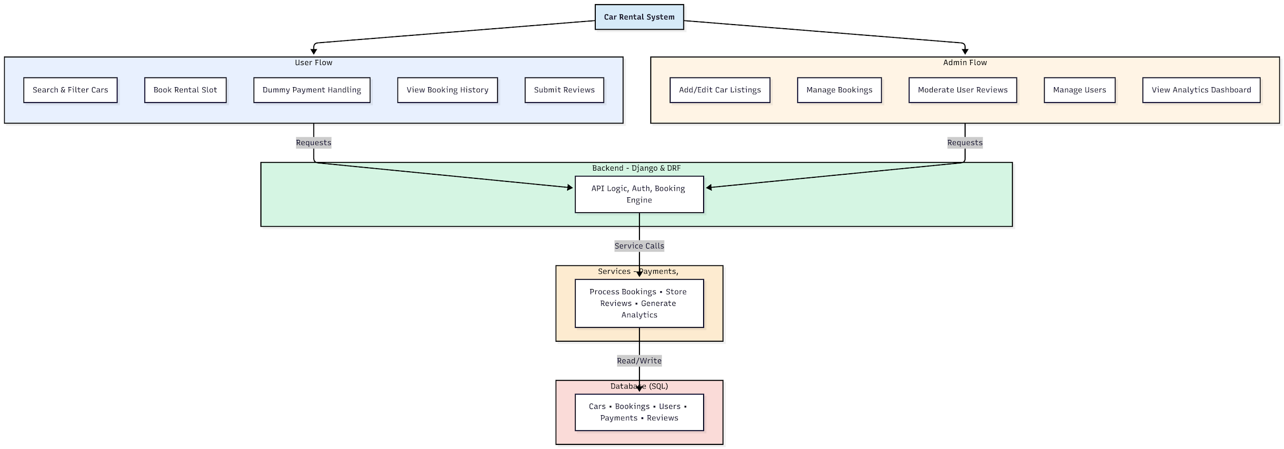

WORKING OF THE PROJECT:
The Car Rental System begins with users browsing and filtering available cars based on model, price, or availability. After selecting a vehicle, users proceed to book rental slots and complete dummy payment verification. Their booking details and history are stored for future reference. The backend manages authentication, booking logic, and communication with database services. Administrators oversee the platform by adding or editing car listings, approving or modifying bookings, moderating user reviews, managing users, and analyzing rental trends using graphical dashboards. The integrated architecture ensures a smooth workflow for both users and administrators..

SOFTWARE REQUIREMENT:
- Backend:
  - Python 3.x
  - Django
  - Django REST Framework
  - SQLite/PostgreSQL
- Frontend:
  - Node.js and npm
  - React.js
  - Axios
- Development Tools:
  - Visual Studio Code
  - Postman (for testing APIs)
  - Git/GitHub (for version control)
- Server/Deployment (Optional):
  - Gunicorn, Nginx, or Heroku/AWS for hosting

ADVANTAGES OF THE PROJECT:

• Real-time car availability and rental booking
• Automated booking, scheduling, and dummy payment handling
• Easy management of fleet data and user information
• Visual analytics for admin decision-making
• Enhanced user convenience and accessibility
• Reduced manual workload and operational errors
• Secure user authentication and data storage
• Reviews that improve fleet quality and customer trust

APPLICATIONS OF THE PROJECT:
• Car rental companies
• Travel and tourism agencies
• Airport transport rental services
• Corporate fleet management
• Hotels offering rental car services
• Local car booking agencies
• Transport service startups
• Online car reservation platforms

REFERENCES:

- Django REST Framework Documentation — Django Software Foundation. Django Documentation. Available: https://docs.djangoproject.com/
- Django REST Framework. DRF Documentation. Available: https://www.django-rest-framework.org/
- React. React Official Documentation. Available: https://reactjs.org/docs/getting-started.html
- Redux. Redux Documentation. Available: https://redux.js.org/introduction/getting-started
- PostgreSQL Global Development Group. PostgreSQL Documentation. Available: https://www.postgresql.org/docs/
- MySQL. MySQL Reference Manual. Available: https://dev.mysql.com/doc/
- Git. Git Documentation. Available: https://git-scm.com/doc
- Node.js. Node.js Documentation. Available: https://nodejs.org/en/docs/
- Axios. Axios Documentation. Available: https://axios-http.com/docs/intro
- Socket.io Documentation – https://socket.io/docs/

